

***FUNDAMENTALS OF PROGRAMMING***

***ASSIGNMENT # 1***

**NAME:Daniyal Ahmed**

**CMS:457165**

**CLASS:ME-15**

**SECTION:B**

**DATE:23/11/2023**

**Question 1**

#include <iostream>

using namespace std;

int main()

{

int num;

cout<<"Enter the number : ";

cin>>num;

cout<<"The factors of "<<num<<" are : "<<endl;

for(int i=1;i<=num;++i){

if(num%i==0){

cout<<i<<"*"<<num/i<<endl;

}

}

return 0;

}

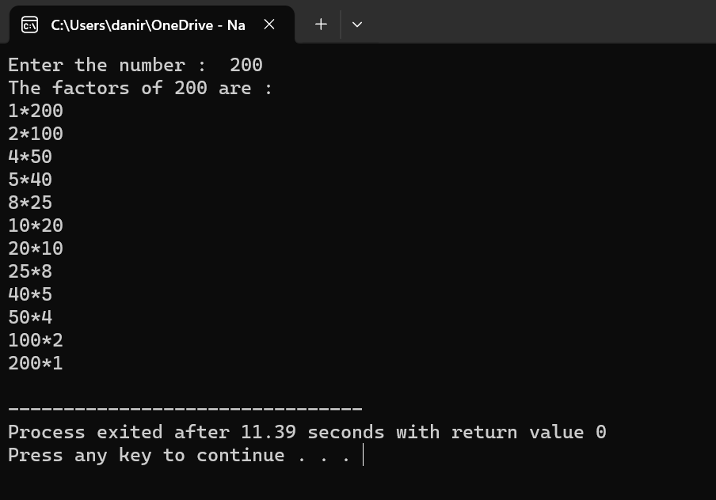

**Question 2**

#include <iostream>

int main() {

int x = 5;

int y = 10;

if (x == 5)

if (y == 10)

std::cout << "x is 5 and y is 10" << std::endl;

else

std::cout << "x is not 5" << std::endl;

return 0;

}

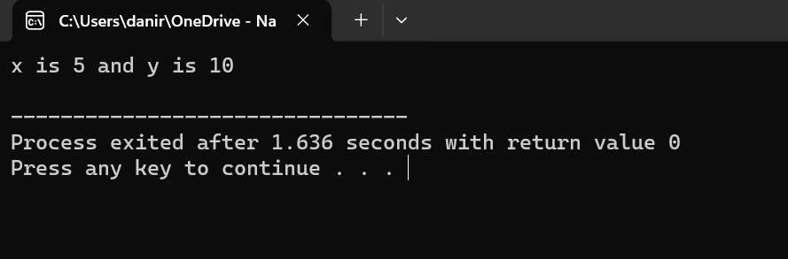

**Question 3**

#include <iostream>

using namespace std;

int main ()

{

int num;

bool condition;

cout<<"Enter the number : ";

cin>>num;

if(num>10 && num<=20){

condition=true;

}

else{

condition==false;

}

cout<<condition;

return 0;

}

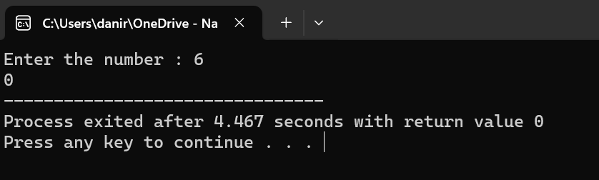

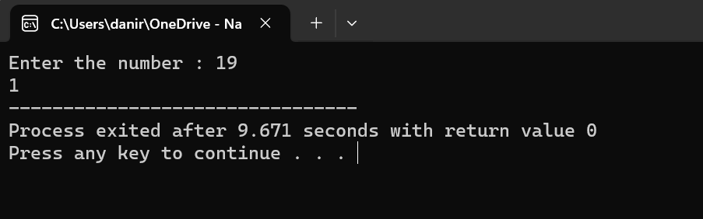

**Question 4**

#include <iostream>

using namespace std;

int main()

{

int num,i;

bool prime;

cout<<"Enter the number : ";

cin>>num;

cout<<"The largest prime number less than "<<num<<" is ";

while(num>=2){

i=2;

prime=false;

while(i<num){

if(num%i==0){

prime=true;

break;

}

++i;

}

if(prime==false){

cout<<num<<" .";

break;

}

--num;

}

return 0;

}

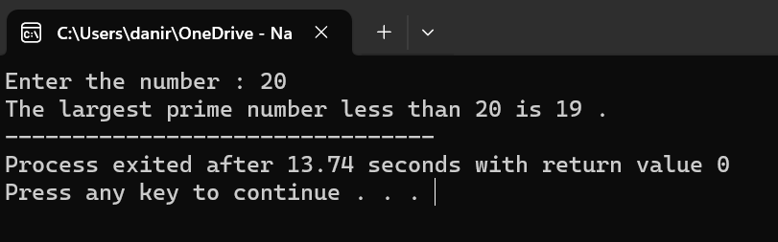

**Question 5**

#include <string>

using namespace std;

int main(){

string s1, s2;

int k;

cout<<"Input the first line of text: ";

getline(cin, s1);

cout<<"Input the second line of text: ";

getline(cin, s2);

if (s1==s2){

k=s1.length();

for (int i=0; i<k/2; i++){

swap(s2[i], s2[k-i-1]);

}

}

cout<<"The first sting is: \t"<<s1<<endl;

cout<<"The second srting is: \t"<<s2<<endl;

return 0;

}

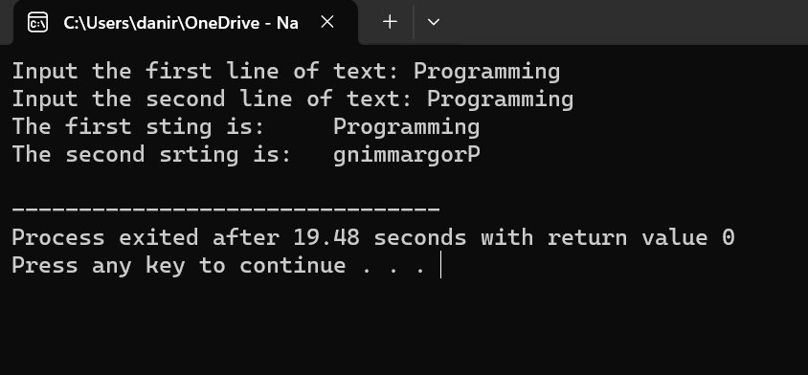

**Question 6**

#include <iostream>

using namespace std;

int main()

{

int num,div;

cout<<"Enter the dividand: ";

cin>>num;

cout<<"Enter the divisor: ";

cin>>div;

for(int Q=1;Q<=num;++Q){

if(num==Q*div){

cout<<num <<" / "<<div<<" = "<<Q;

break;

}

}

return 0;

}

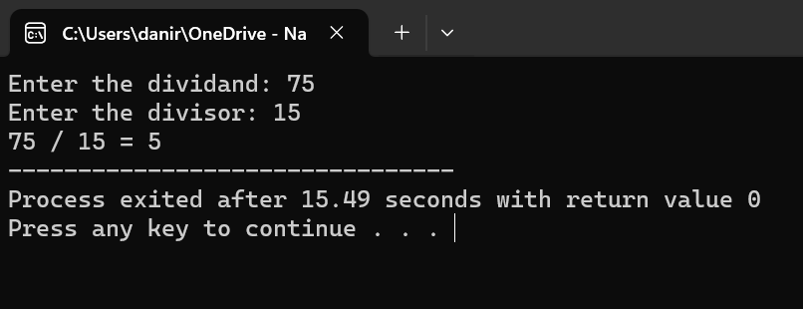

**Question 7**

#include <iostream>

#include <string>

using namespace std;

int main(){

string a;

int l;

cout<<"Enter your string : ";

getline(cin, a);

l= a.length();

for (int i=0; i<=l; i++){

for (int j=0; j<=l; j++){

if (tolower(a[i])==tolower(a[j]) && i!=j){

a.erase(j, 1);

j--;

l=a.length();

}

}

}

cout<<a;

return 0;

}

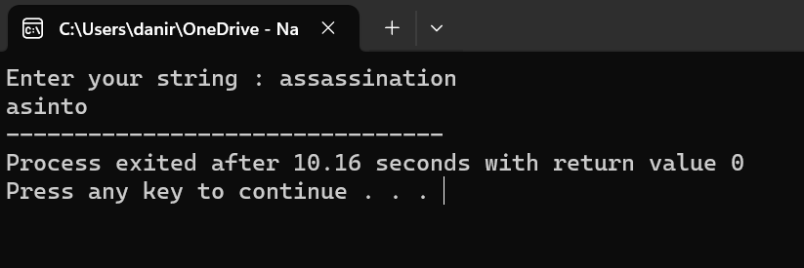

**Question 8**

#include <iostream>

using namespace std;

int main(){

int arr[50]={1,2,3,4,5};

cout<<"Input digits into the array."<<endl;

cout<<"Enter 0 to stop the input stream and display the array."<<endl;

for (int i=5; i<=49; i++){

cin>>arr[i];

if (arr[i]==0){

break;

}

}

cout<<"The current values stored in the array are: \n";

for (int j=0; j<=49; j++){

if (arr[j]==0){

break;

}

cout<<arr[j]<<"\t";

}

return 0;

}

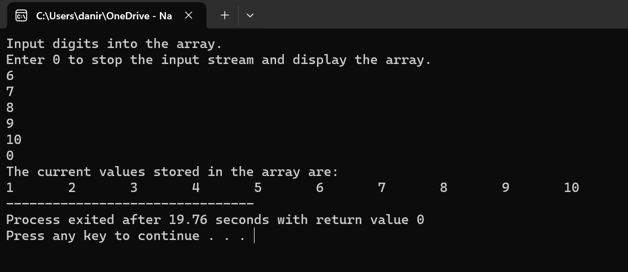

**Question 9**

#include <iostream>

using namespace std;

int main(){

int length, arr[length], num, j, k, l;

bool condition=false;

cout<<"Input the length of the array: ";

cin>>length;

cout<<"Input the values in the array: \n";

for (int i=0; i<length; i++){

cin>> arr[i];

}

cout<<"Input a number: ";

cin>>num;

for(j=0; j<length; j++){

for(k=j+1; k<length; k++){

for (l=k+1; l<length; l++){

if (arr[j]+arr[k]+arr[l]==num){

condition=true;

break;

}

}

if(condition==true){

break;

}

}

if(condition==true){

break;

}

}

cout<<num<<" is the sum of "<<arr[j]<<"(Array's "<<j+1<<" value) ,"

<<arr[k]<<"(Array's "<<k+1<<" value) & "

<<arr[l]<<"(Array's "<<l+1<<" value)";

return 0;

}

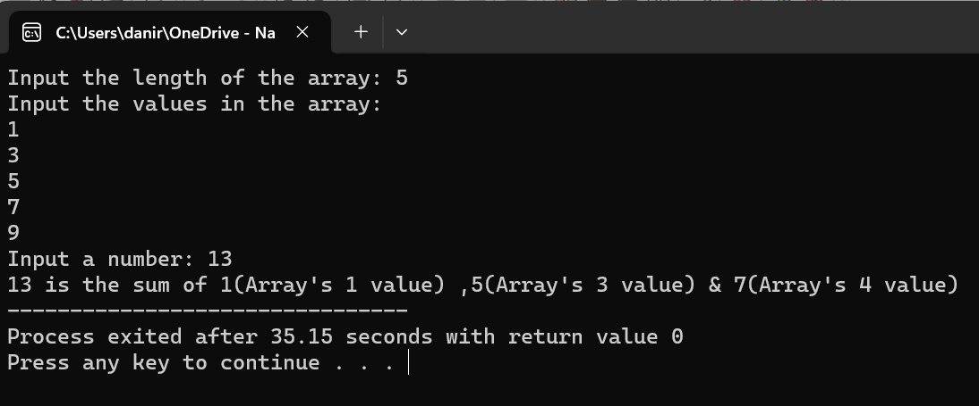

**Question 10**

#include <iostream>

using namespace std;

int main(){

int arr[6];

cout<<"Enter the six numbers in the array : \n";

for(int i=1;i<=6;++i){

cin>>arr[i];

}

for(int j=1;j<=6;++j){

for(int k=1;k<=6;++k){

if(arr[k]>arr[k+1]){

swap(arr[k],arr[k+1]);

}

}

}

cout<<"The values sorted in ascending order are : \n";

for(int a=1;a<=6;++a){

cout<<arr[a+1]<<endl;

}

return 0;

}

